# DIS-Asia-Indus Valley- Tel Halaf Female Fertility Figurine. 6100-5400 BCE. Terracotta.

# Indus Tel Halaf Female Fertility Figurine. 6100-5400 BCE. Terracotta. 47.13 grams , 72mm x 42mm x 36mm. Very Fine.

# Order details

Printer friendly page

## Sales order

Sold by [silverdenar](http://myworld.ebay.com/silverdenar) ( [741](http://feedback.ebay.com/ws/eBayISAPI.dll?ViewFeedback&userid=silverdenar) )

+ Show additional actions

### Delivery package 1 of 1

Estimated delivery Wednesday, Jun 8, 2016 -Thursday, Jun 23, 2016

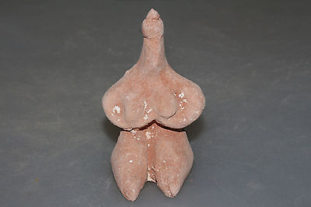

#### [Tel Halaf Terracotta Idol Female Statue 6100-5400 BC](http://www.ebay.com/itm/112006602104)

|  |  |
| --- | --- |
| **Item price** | $149.99 |
| **Quantity** | 1 |
| **Item number** | 112006602104 |
| **Shipping service** | Economy Shipping from outside US |

[Leave feedback](http://feedback.ebay.com/ws/eBayISAPI.dll?LeaveFeedbackShow&useridfrom=802-867&useridto=silverdenar&item=112006602104&transactid=1524018828001)

[Contact seller](http://contact.ebay.com/ws/eBayISAPI.dll?FindAnswers&frm=3998&iid=112006602104&redirect=0&requested=silverdenar)

[Return item](https://www.ebay.com/rtn/Return/ReturnViewSelectedItem?transactionId=1524018828001&itemId=112006602104&_trksid=p2057872.m2749.l3185)

## Shipping address

Ralph J Coffman Jr

149 Atlantic Ave

Swampscott MA 01907-2427

United States

## Order total

|  |  |
| --- | --- |
| **Subtotal** | $149.99 |
| **Shipping** | $10.00 |

**Total**

$159.99